PCB MULTILAYER (until 8 Layer).docx

Multilayer PCB (up to 8 layers) with tracks and plated-through holes at home.

PCBs make prototypes at home, it has indisputable advantages of cost savings and time.

The challenge is to do with the resolution (multilayer) and reliability of entrusting them to an external company.

This problem come by suffering all hackers in each new project.

This project (EBC Bilateral Brain stimulator) equipment for EMDR stood to devote to solve this problem that has taken me over a year.

I can now say that I have been satisfactorily resolved and I can make prototypes up to 8 layers with metallized tracks and drills step.

I show you a simple example.

Later I will post a project time explaining the whole process.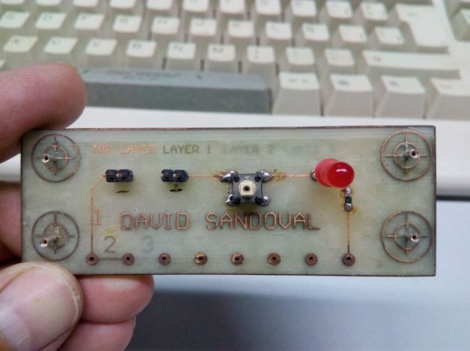 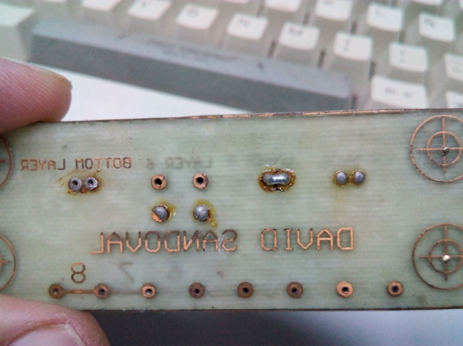

8 layers PCB tracks chained in series metallized in my lab with my procedure. 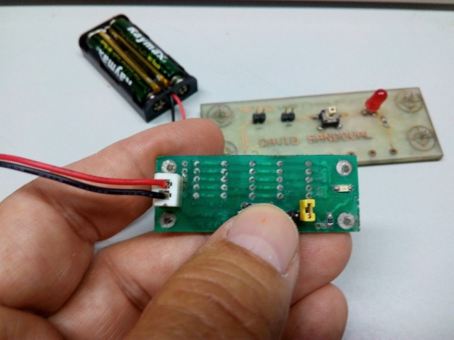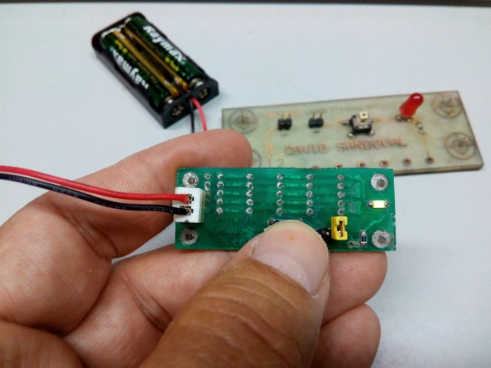

Two layer PCB with 35-way tracks chained by forming a series circuit. On the left led off. On the right led on. Resistance of 0.06 Ohm via below.

In my project I have not yet implemented this system, as I have done according to had made. Solder mask rather there are some improvements, but I'm on it.

In the next post I send some photos with the prototypes of the project to begin programming.

Greetings.